**Microsoft Certified Associate: Azure Architect Technologies AZ-303**

Course-End Project

For Caltech/Simpilearn

Michael Whitehead

May 24, 2021

**Course-End Project: Implement Azure IaaS**

**Project objective:**

The Rand Enterprises Corporation wants to test ARM template deployment to bring infrastructure as code into practice. They have decided to work on project RandEnt to verify the functionality.

The operations team at Rand decides to define the entire networking architecture using the ARM template, once that’s in place they intended to create the storage account along with virtual machines housing their application.

**Background of the problem statement:**

Rand Enterprises works extensively on delivering Image-based content for their global audience in a secure way by avoiding Azure Storage account access to the public internet. The communication from the application in the VM to the Azure Storage account must take place via the internal network of Azure.

The expectation of the operation team is to Rather than deploying resources in Azure independently, they should leverage Azure ARM templates to deploy and provision all resources in templatize format.

**Following requirements should be met:**

* Define the network
* Extend that with Compute & Storage
* Create the Storage account container for Images & configure service endpoints

Step 1: Download the following ARM template files from the attached Google doc path:

Step 1: Create a Resource Group

1.1 Open your windows Powershell as administrator and connect to you Azure Account by using the below command

Connect-AzAccount

1.2 Enter your Lab credentials and proceed

1.3 Create a Resource Group

* New-AzResourceGroup -Name ProjecttestAz300 -Location EastUS

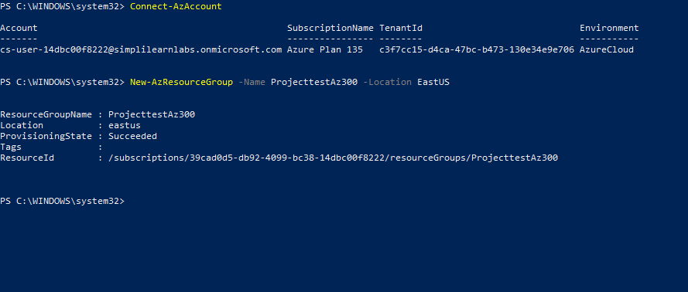

Step 2: Deploy VM Creation Template

* New-AzResourceGroupDeployment -ResourceGroupName ProjecttestAz300 -Templatefile C:\Users\Anjana\Downloads\Vm\Vm\template.json
* Enter User name and password when prompted

**Note:** **Here the path mentioned is of the templates saved in your system. You can download the templates from the below google drive for your reference and then can use the path after downloading it. however, the trainer in Live class will help you with the Templates**

https://drive.google.com/drive/folders/1fouOko5ndoXEbKKmRvKKbRn38J9fYQbR

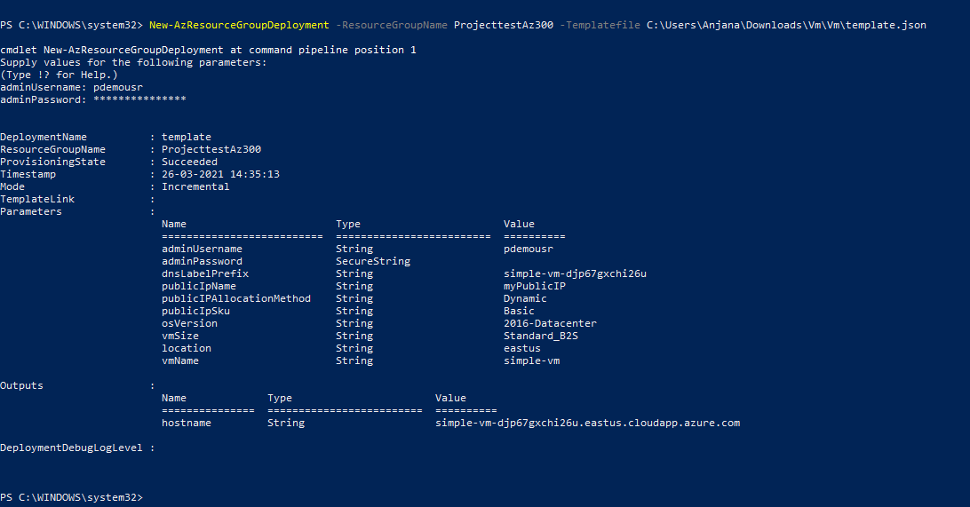

Step 3: Deploy Storage Template

* PS C:\WINDOWS\system32> New-AzResourceGroupDeployment -ResourceGroupName ProjecttestAz300 -Templatefile C:\Users\Anjana\Downloads\Storage\template.json
* Enter the below details when prompted:

1. **location**: EastUS
2. **accountType**: Standard_LRS
3. **kind**: StorageV2
4. **accessTier**: Hot
5. **supportsHttpsTrafficOnly**: true

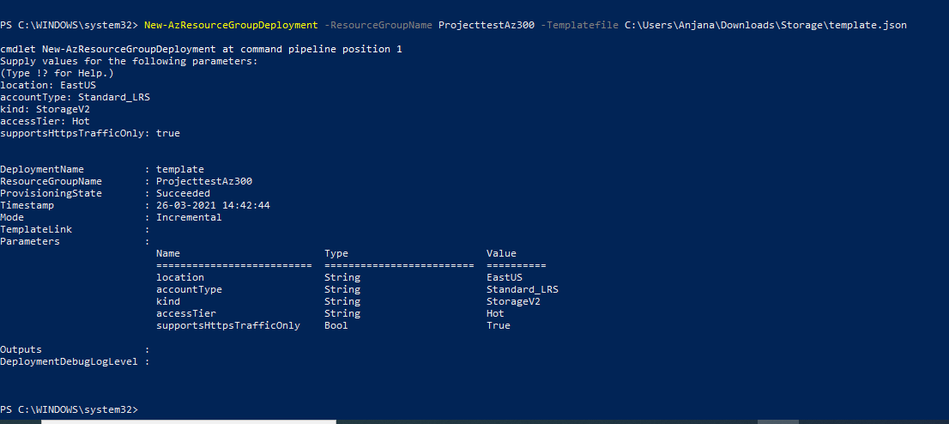

3.1 Once the storage account is created, create a container within it named as **images** and then upload an image in it keeping **Public Access Level**: Anonymous read access for container and blobs

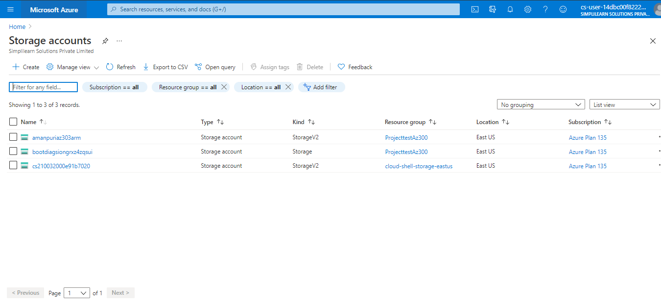

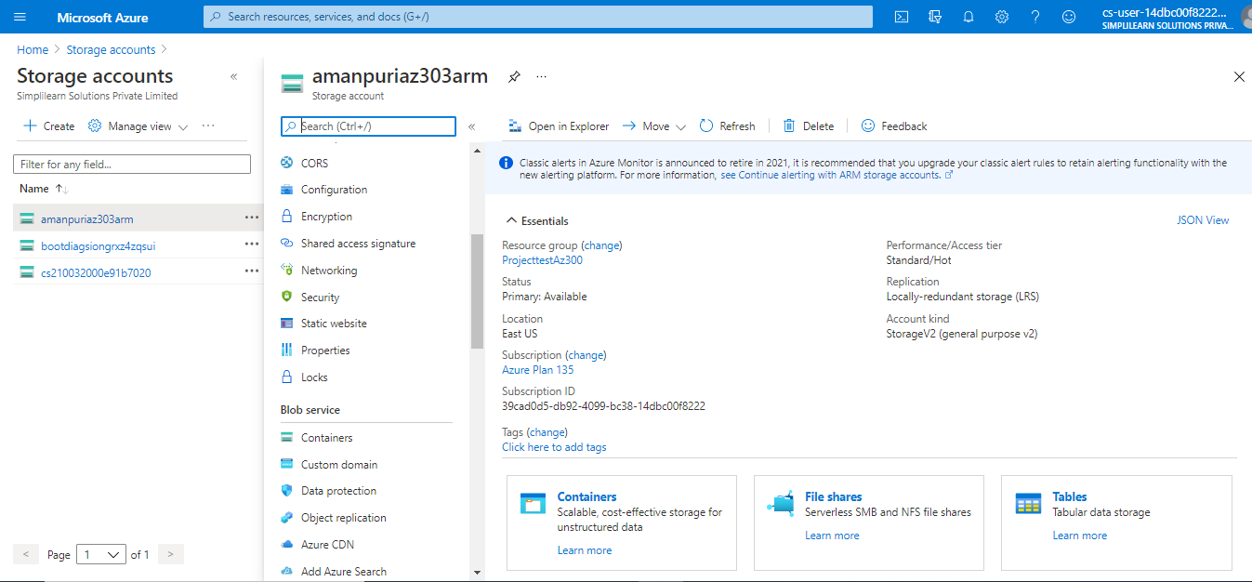

Public Access Level: Anonymous read access for container and blobs

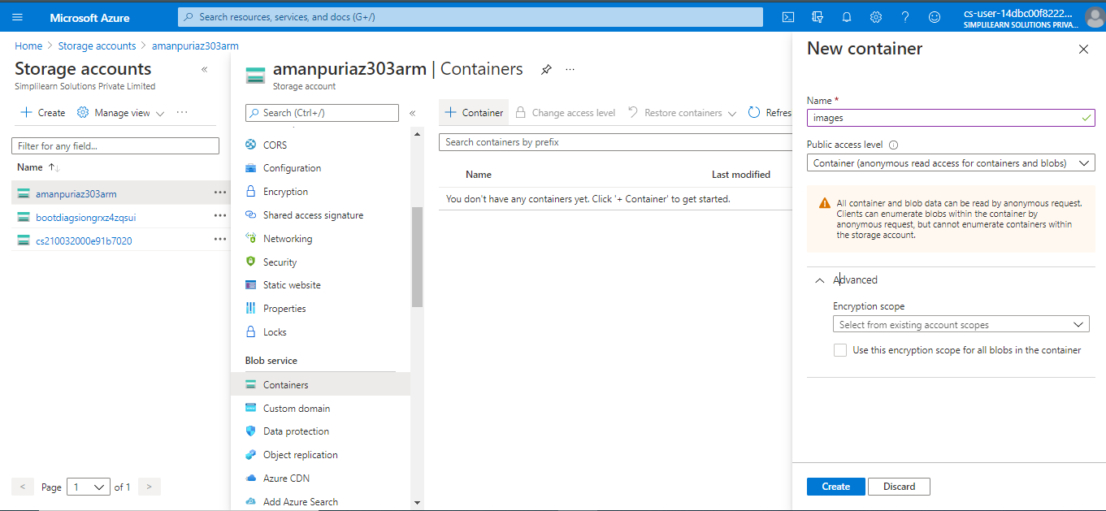

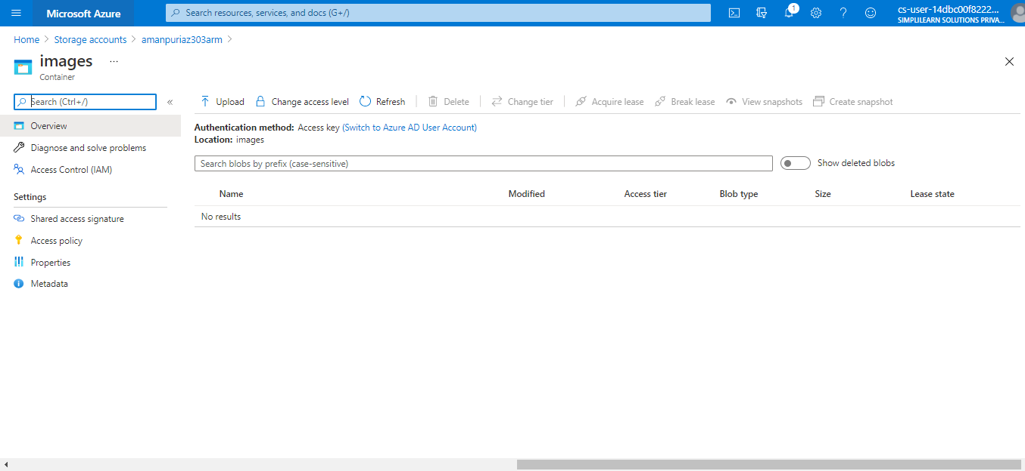

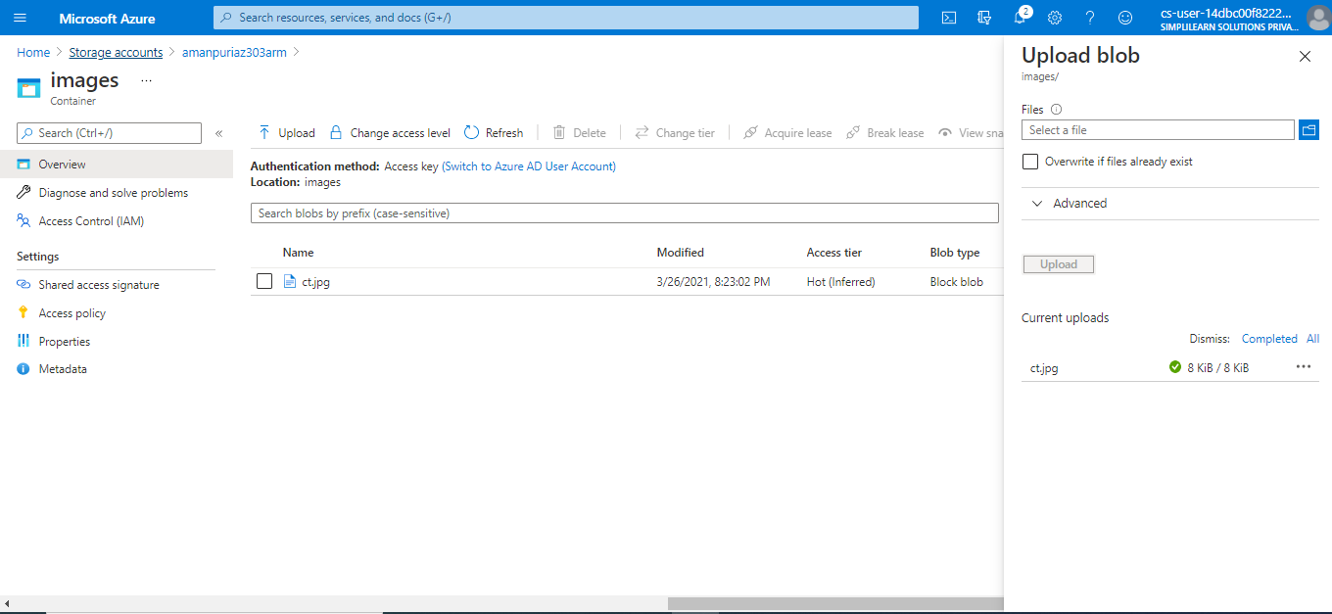

Note: CDN Template should have the updated Storage URL under Hostname option at every place.(The one you created)

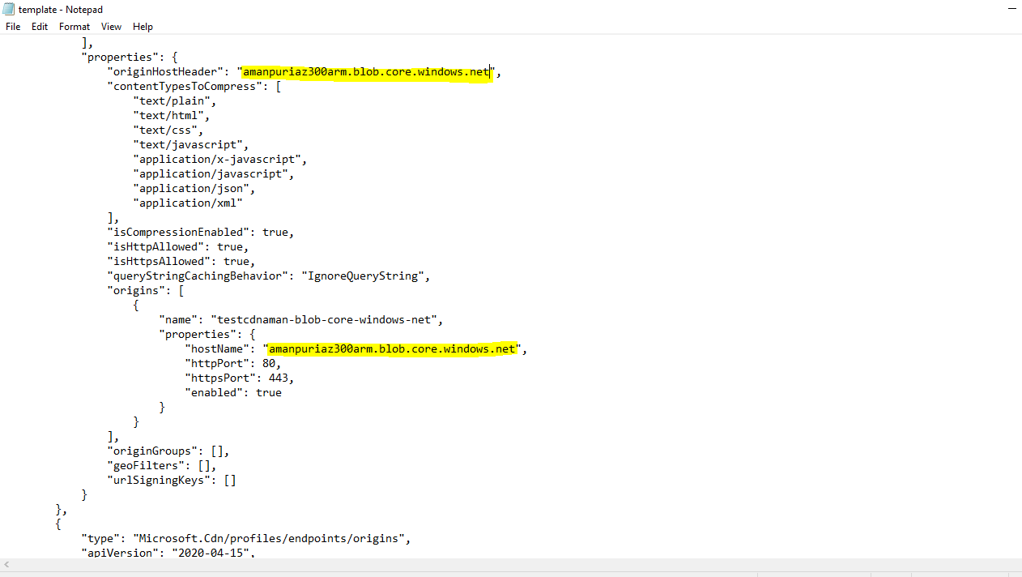

Step 4: Deploy the CDN Template

4.1 Once the CDN template is updated with the storage URL deploy the template in powershell

* PS C:\WINDOWS\system32> New-AzResourceGroupDeployment -ResourceGroupName ProjecttestAz300 -Templatefile C:\Users\Anjana\Downloads\CDN\template.json

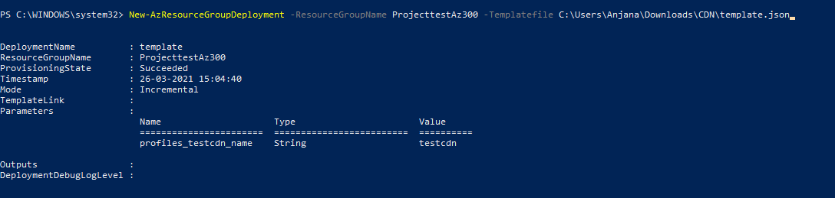

Step 5: Configuring Service Endpoint

* Once the CDN profile is created, use the service endpoint to verify your deployment. It takes 15+ minutes for the CDN URL to work. Once deployed, you will be able to view the image uploaded.

User the URL in below format:

endpoint URL/container name/image name

Here in this case it is: <http://imagesendpoint.azureedge.net/images/ct.png>

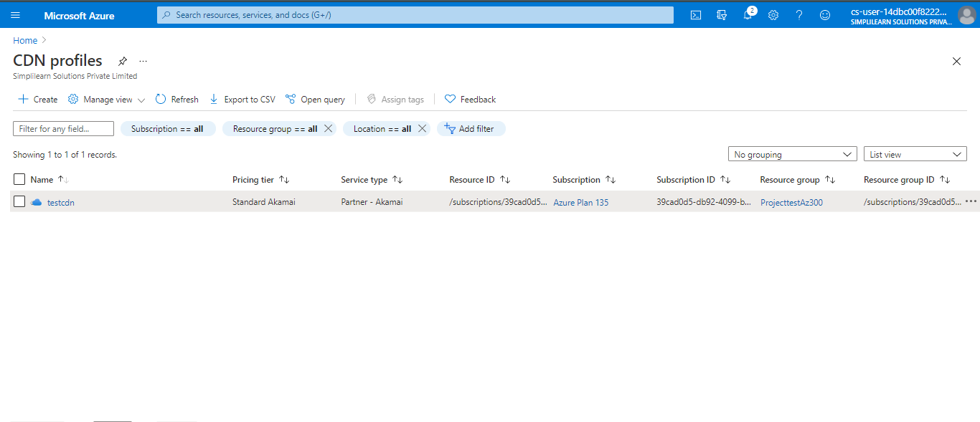

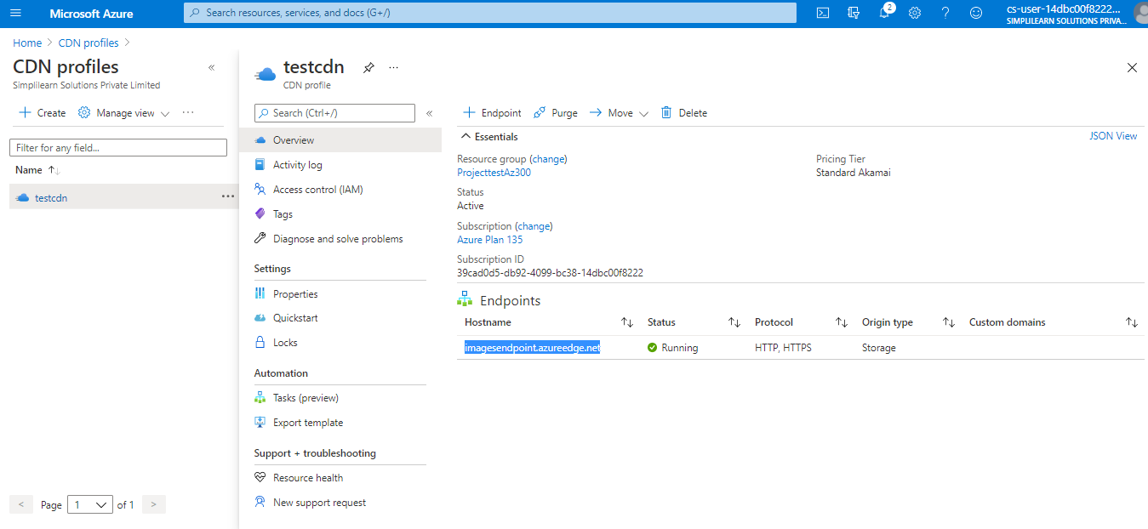

It takes around 15 minutes or more for the CDN URL to work

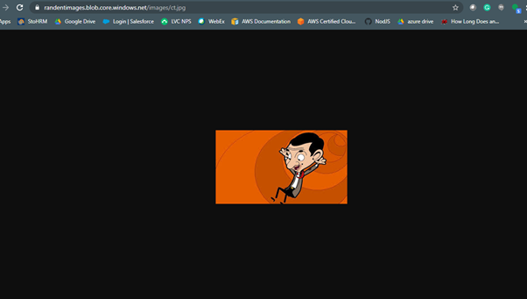

Powershell Troubleshoot:

In case you get connecting to your azure account using PowerShell, please perform the below commands.

**Make sure you are using PowerShell as a administrator.**

Set-ExecutionPolicy Unrestricted

Install-Module -Name Az -Scope CurrentUser -Repository PSGallery -Force

Import-Module Az.Accounts

Connect-AzAccount